### INF 551 Project Midterm Report

Wanjin Li Taoran Ju Hyun Jun Choi

{wanjinli} {taoranju} {choi797}

1. **Overview**

Our idea is developing an Android application called *diSCover*. It is designed for USC community includes students, faculty and alumni, to recommend good resources in USC campus and share their extraordinary experiences to each other. Students can post photos, pictures and write several texts to describe the item, and other students can ask question and chat with the author through the app. We use Firebase as the database to store all the data and resource, and implemented the app via MVC structure.

1. **Realized Functions**
   1. **Log In**

Users can log in with email and password. If users have not chosen profile images, they will enter into the set-up page. Then they can choose a favorite picture as profile image and input their nickname. If they have finished the set-up part, they can directly enter homepage.

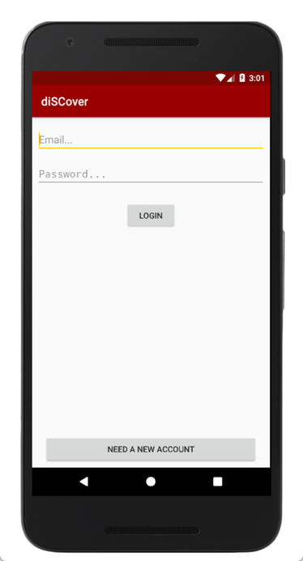 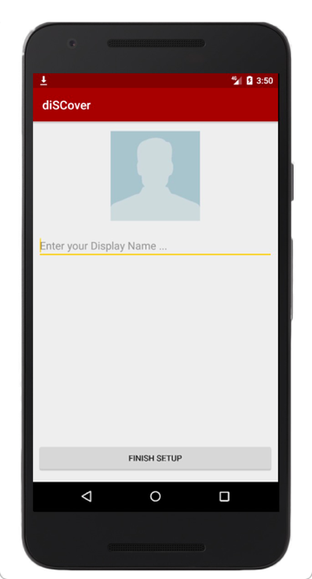

Fig. 1 Log In page & Set Up page

* 1. **Create Account**

If users do not have accounts, they can click the “need a new account” in the log in page, then they can register accounts by email.

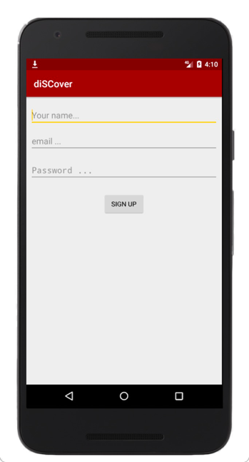

Fig. 2 Register page

* 1. **Recommendations Display**

It is the homepage and the first page for user who has complete sign in/sign up or has already signed in. In this page, user is able to see all the recommendations that display by post time. In each piece of recommendation, it shows the title of contents, text description and the picture.

In this page, user can also click the ‘+’ button above the page to enter the post new recommendation page, click the setting button to edit his profile or click log out button to exit.

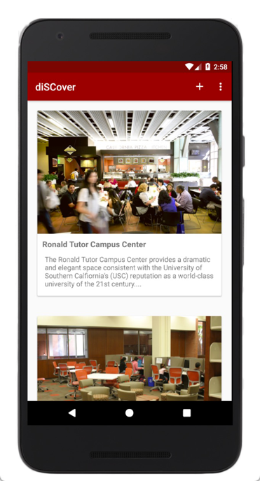

Fig. 3 Homepage

* 1. **Post Contents**

In the post page, users can create and post their own recommendation. For each piece of recommendation, they can attach a picture, add a title and some text description. Then by click the submit button, this piece of recommendation can be uploaded to the list of all posts, and page will jump back to the home page where user can see this post.

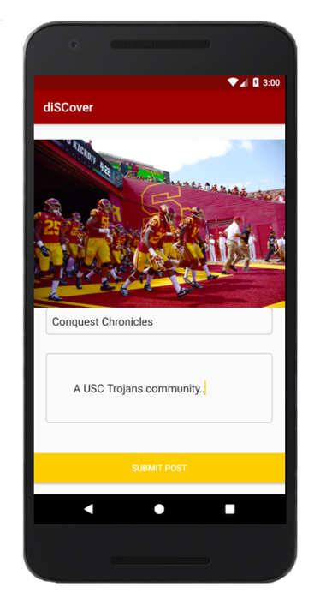

Fig. 4 Post Recommendation Page

1. **Data Storage**
   1. **Storage**

Storage in firebase is designed for keeping media resources like picture, audio and videos. We use storage to store all the image files. Profile_images file folder contains the photos of user profile and Post_Images file folder contains the pictures user upload when post recommendation. Each image in Storage has a unique URL address which can be store in the Database later to infer to this file.

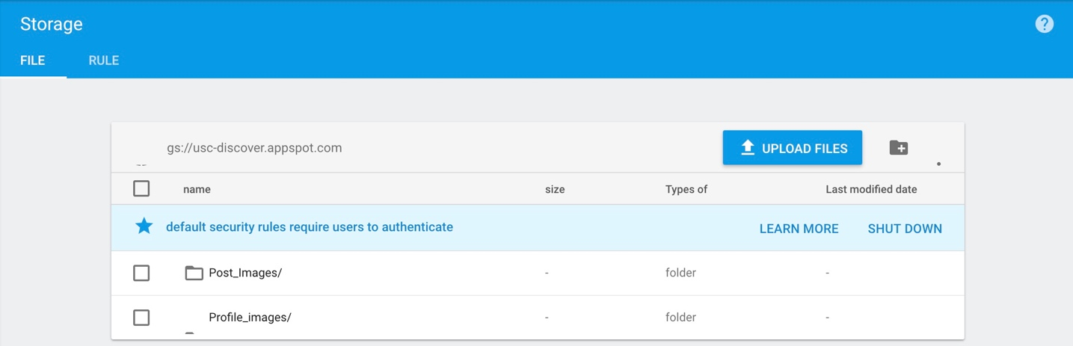

Fig. 5 Storage in Firebase

* 1. **Database**

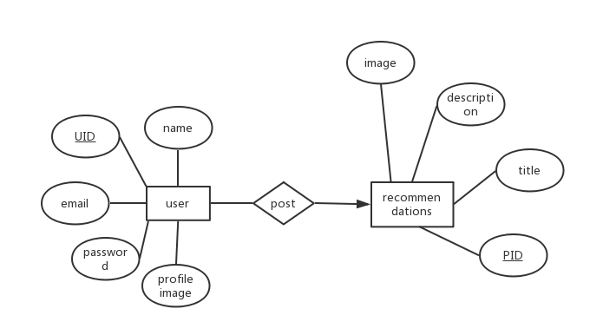

Fig. 6 ER diagram

The realtime Database in Firebase is a NoSQL, JSON and cloud hosted database, we use it to store the user information and post records. Within the Users group, it generates a unique UID for every user when they register at the first time. For each user, we store the url of user’s profile image in Storage and the username.

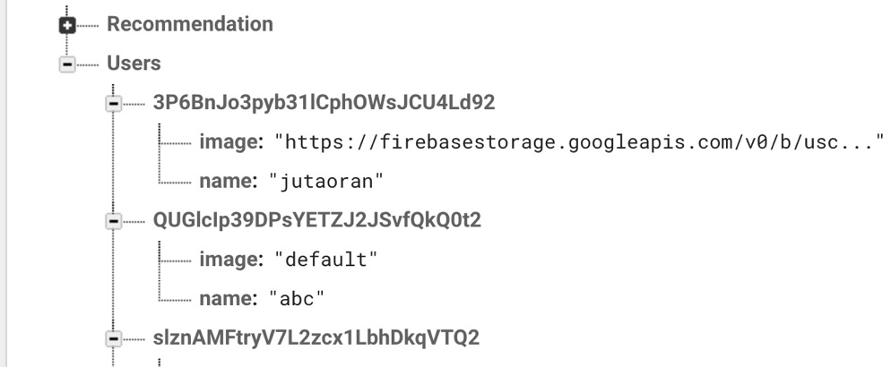

Fig. 6 User records in database

Within the Recommendation group, it generate a unique PID for every post. Specifically, it contains the title of post, text description and the URL of picture in Storage.

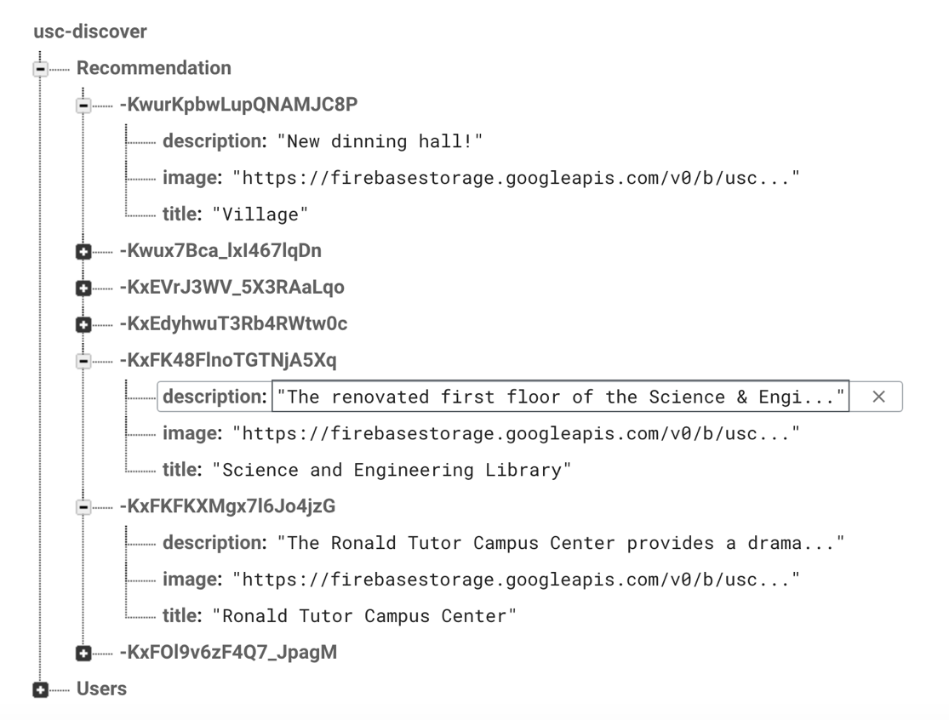

Fig. 7 Post records in database

* 1. **User Interface**

We use Java to develop an Android app, and choose API in level 26 which is the newest edition. When design the UI, we use the representative USC style. We also import some external library like Picasso, Butterknife and Firebaseui to make the user interface more friendly and good-looking.

1. **Challenges & Changes**
2. In the part of login, there are many activities and we need to switch between these activities. At first, we could not switch activities correctly. Then we used the Log function to help debug the code and found the mistake and solved the problem.
3. At first, we decide to implement the app based on MVP structure(Model-View-Presenter), we even have realized the login function. However, we found out the data that needed to be processed were not such large and MVP structure was too complex for some simple switch between different activities. Thus, we gave up the original structure, and implanted the current MVC structure.
4. **Future Work**
   1. **Chatting Function**

By connecting chatting function with firebase, diSCover can collect real time data from users. After collecting data, it can analyze data and extract meaningful information in real time. This function plays an important role in recommending information in which each user is interested in real time.

* 1. **Google Map API(Optional)**

If time permits, we want to use google map to mark the location when users post their recommendation, and people can also find places in the map. In the backend, we should also save the location’s latitude and longitude.

* 1. **Capture Information from Website Automatically**

We want to extend our app to automatically collect events and activities of USC from websites. Jsoup is a Java library for working with real-world HTML. It provides a very convenient API for extracting and manipulating data, using the best of DOM, CSS, and jquery-like methods. Therefore, we can implement Jsoup open source java library in our android application.

* 1. **Optimization of Recommendation Post**

So far we have completed the basic and main function of recommendation. We still plan to optimize this part as it is the core idea of the app. We may improve some functions like uploading multiple pictures and adding category label. We also want to improve the UI more user friendly.

1. **Team Information**
   1. **Responsibility**

|  |  |
| --- | --- |
| NAME | WORKLOAD |
| Wanjin Li | Post/Hompage |
| Taoran Ju | Login/Create Account |
| Hyun Jun Choi | Chatting |

* 1. **Timeline**

So far, we have completed all the assignment before midterm contains the app structure establishment, user login/creation, post and display recommendation function. According to the timeline, we will start to develop chatting function from now. We expect to complete the project on time.

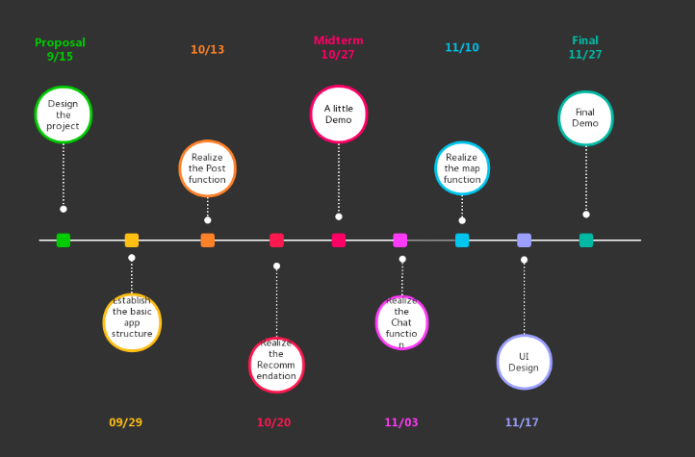

Fig. 8 Timeline